**Lab Assignment 2**

Operating Systems

Submitted to:

Dr. Anjali Gautam

Submitted by:

Godala Sukumar Reddy(2020BTechCSE032)

Institute of Engineering and Technology (IET)

JK Lakshmipat University, Jaipur

August 2022

CAT Commands

RM commands

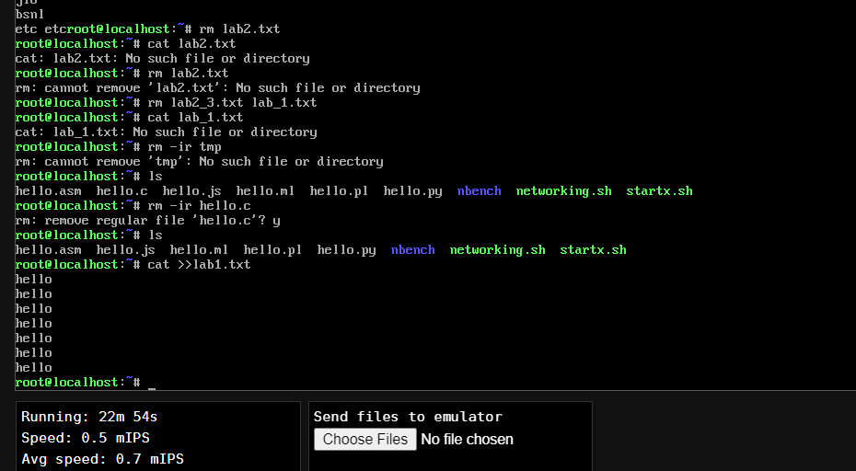

**CD** commands

**CP** commands

LS commands

MKDIR commands

RMDIR commands

WC commands

MORE commands

HEAD commands

TAIL commands

